Real-Time Vision-Based Pothole Detection and Speed-Scaled Risk Alerting System for Micro-Mobility Users

Wan Mohd Yaakob Wan Bejuri¹, Muhammad Al Ieqbal Nur Haqiemi bin Abdul Khalid¹
Faculty of Artificial Intelligence and Cyber Security, Universiti Teknikal Malaysia Melaka, Melaka, Malaysia
Article Info |  | ABSTRACT
Article history:  Received Jan x, 2024  Revised Mar x, 2024  Accepted Apr x, 2024 |  | The rapid expansion of micro-mobility vehicles, such as electric scooters and bicycles, has introduced new challenges for urban transportation safety. Due to small wheel diameters and a lack of active suspension systems, micro-mobility riders are exceptionally vulnerable to road surface defects like potholes, which can cause immediate loss of vehicle control and severe injury. Existing hazard mapping and warning systems are either reactive, cost-prohibitive, or dependent on active cloud server connections, making them impractical for real-time rider protection on the edge. This paper proposes a fully offline, vision-based pothole detection and safety risk assessment system deployed on a standard smartphone. The system utilizes an optimized, 8-bit quantized TensorFlow Lite (TFLite) YOLOv8 Small model trained on a single-class dataset of 1,302 images. To minimize false alarms and capture safety severity dynamically, we formulate a velocity-scaled exponential Risk Index algorithm that calibrates visual warnings and audible beeps based on real-time GPS speed. The system executes on-device inference in under fifty milliseconds per frame on consumer hardware. Experimental results show that the YOLOv8 Small model achieves a validation mean Average Precision (mAP50) of 95.8%, outperforming the Nano (93.9%) and Medium (94.5%) model scales, while maintaining a lightweight footprint of approximately 12.2 MB. This system successfully demonstrates the feasibility of real-time deep learning on the edge to actively protect vulnerable urban travelers.
Keywords:
Artificial intelligence
Deep learning
Edge computing
Object detection
Real-time risk index
Micro-mobility safety
YOLOv8 Small

This is an open access article under the CC BY-SA license.

Corresponding Author:
Wan Mohd Yaakob Wan Bejuri
Fakulti Teknologi Maklumat dan Komunikasi, Universiti Teknikal Malaysia Melaka
Melaka, Malaysia
Email: yaakob@utem.edu.my

- INTRODUCTION
The modern landscape of urban transportation safety technology is heavily biased toward passenger cars and commercial vehicles, often leaving micro-mobility users, including cyclists and electric scooter riders, exposed to severe physical vulnerability. The rise of micro-mobility platforms as a key solution for first-and-last-mile transit has highlighted a major infrastructural safety gap. Unlike cars, micro-mobility vehicles possess small wheel diameters (ranging from 8.5 to 26 inches) and lack active suspension, meaning minor road surface anomalies that are trivial for passenger cars can cause immediate loss of control, falls, and severe injuries for riders. Despite this vulnerability, popular navigation systems like Google Maps do not offer granular, real-time alerts for localized surface defects, forcing riders to rely on reactive visual reactions that fail at higher cruising speeds or in low-light conditions.

To address these safety challenges, several road hazard mapping systems have been proposed in the literature, falling generally into tactile, range-finding, and visual inspection categories. Tactile systems utilize smartphone accelerometers to log road vibration. While computationally simple, they are purely reactive, registering the pothole only after the rider has experienced the impact, which does not prevent accidents. Range-finding systems using LiDAR sensors offer high accuracy but are cost-prohibitive, require custom hardware integration, and consume high electrical power, making them unsuitable for consumer mobile deployment. Visual inspection systems typically rely on vehicle-mounted cameras and cloud processing, which lacks real-time warning capabilities for individual riders due to cellular latency. Therefore, a proactive, low-cost, offline-first warning system that executes deep learning inference locally on a rider's smartphone is highly desirable.

This paper presents the design, implementation, and evaluation of an AI-powered real-time pothole detection and risk alerting system optimized for micro-mobility edge deployment. The system integrates a lightweight convolutional neural network with a mobile application interface to deliver speed-calibrated audio-visual safety warnings. The primary contributions of this work are threefold. First, we benchmarking and deploy a compressed, 8-bit quantized YOLOv8 Small model running locally on a mobile device with a frame latency of under fifty milliseconds. Second, we propose a mathematically formal, velocity-scaled exponential Risk Index algorithm that dynamically scales warning severity based on kinetic energy dynamics. Third, we develop an offline-first Flutter application featuring a Strava-style stats dashboard and an aggregate historical hazard map using local OpenStreetMap tiles, transforming individual rides into active community infrastructure monitoring sessions.

- Proposed System Architecture and Dynamic Risk Algorithm

2.1. Object Detection Engine and Optimization
The core detection component is built upon the Ultralytics YOLOv8 architecture. To optimize the model for execution on budget mobile hardware, we benchmarked three model scales: Nano (~3.2M parameters), Small (~11.2M parameters), and Medium (~25.9M parameters). The models were trained on the single-class pothole-vhmow dataset consisting of 1,302 road images. Training was conducted for 50 epochs with a resolution of 320x320 pixels. After training, the PyTorch weights (.pt) were converted to TensorFlow Lite (.tflite) format. To minimize on-device RAM usage and CPU inference latency, post-training 8-bit integer quantization (INT8) was applied using representative calibration datasets. The quantization process compresses the YOLOv8 Small model size from 22.5 MB to 12.2 MB, enabling fast execution via the TensorFlow Lite Interpreter on the mobile device.

2.2. Velocity-Scaled Exponential Risk Alerting Model
Static bounding boxes and distance-based thresholds are insufficient for rider safety because the danger posed by a road defect scales with the vehicle's speed. To capture this relationship, we formulate a dynamic Risk Index RI algorithm:
$$RI = \left(\frac{S_{detected}}{S_{threshold}}\right)×{\left(\frac{V_{current}}{V_{limit}}\right)}^{2}× 100\%$$
In this formulation, $S_{detected }$represents the bounding box area in pixels, serving as a proxy for pothole size and proximity, while $S_{threshold }$represents the maximum bounding box size. The vehicle's real-time speed, retrieved at 1 Hz from the device's GPS sensor, is denoted by $V_{current}$, and $V_{limit}$ is the speed threshold based on the vehicle profile (e.g., 25 km/h for e-scooters and 40 km/h for bicycles). Squaring the velocity ratio scales the Risk Index exponentially, representing the kinetic energy scaling $K.E. = \frac{1}{2}{mv}^{2}$ of the vehicle. When the Risk Index exceeds a safety threshold of 75%, the alert engine triggers a high-contrast red HUD screen flash and plays high-frequency audible warning beeps, while detections below this threshold are rendered with standard bounding boxes to prevent driver distraction.
The logical flow of the frame processing loop and risk evaluation is detailed in the flowchart below:
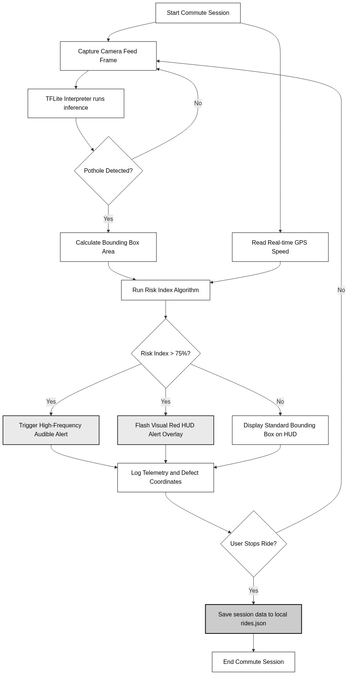
Figure 1: System Workflow Flowchart

2.3. Mobile Application Architecture
The mobile application is structured using a clean, three-tier architecture to ensure modularity and offline-first reliability, as illustrated in the system diagram:
- Presentation Layer: Built with Flutter, implementing a BottomNavigationBar navigation hub containing a Strava-style Dashboard feed, a Live Record HUD camera stream, an interactive Hazard Map, and a Settings panel.
- Logic Layer: Manages TFLite model inference, GPS speed listening, the exponential Risk Index calculations, and the audio-visual warning triggers.
- Persistence Layer: Saves ride telemetry and pothole coordinates locally in rides.json and user configurations in settings.json, guaranteeing full offline functionality without server dependencies.
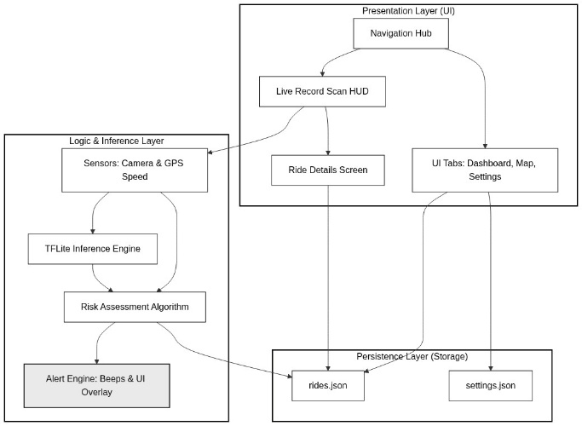
Figure 2: Compact Three-Tier System Architecture

- RESULTS AND DISCUSSION
3.1. Dataset and Workstation Model Training
The dataset utilized is the single-class pothole-vhmow dataset extracted from Roboflow, containing 1,302 images representing various road angles, lighting conditions, and road surfaces. Model training was performed on a workstation equipped with an AMD Ryzen 7 CPU and an NVIDIA GeForce RTX 3050 Laptop GPU using PyTorch and CUDA acceleration. The training curves generated show that the models converged smoothly. The bounding box loss and classification loss dropped steadily, and validation metrics stabilized after the 40th epoch without showing signs of overfitting.
Below are the actual training graphs, confusion matrix, and precision-recall curves for the selected YOLOv8 Small model:
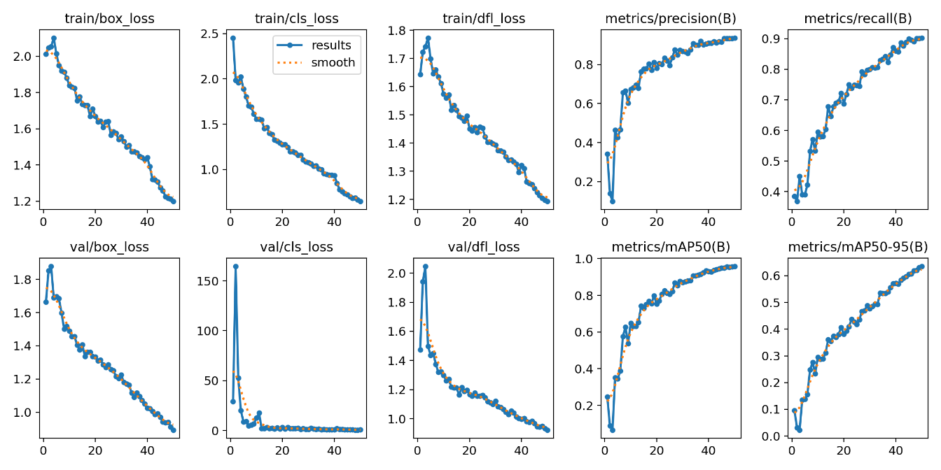
Figure 3: Training and Validation Loss Curves
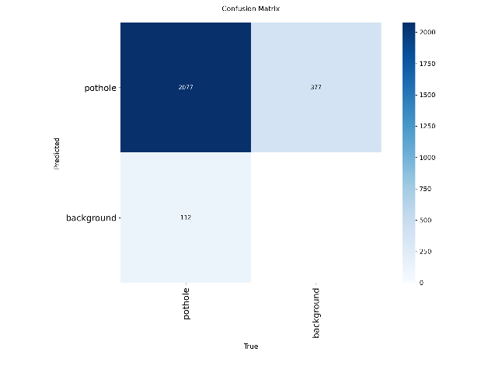
Figure 4: YOLOv8 Object Detection Confusion Matrix

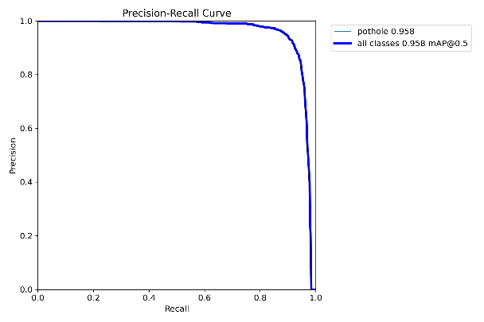
Figure 5: Precision-Recall (PR) Curve

3.2. Quantitative Performance Comparison
Table 1 compares the performance metrics of the three trained YOLOv8 scales evaluated on the validation dataset.

Performance Metric | YOLOv8 Nano | YOLOv8 Small | YOLOv8 Medium
Model Parameter Count | ~3.2 Million | ~11.2 Million | ~25.9 Million
Training Time (50 Epochs) | 382 seconds | 804 seconds | 1,413 seconds
Validation Precision | 91.7% | 93.7% | 92.3%
Validation Recall | 88.8% | 90.3% | 90.2%
mAP at IoU=0.5 (mAP50) | 93.9% | 95.8% | 94.5%
mAP at IoU=0.5:0.95 | 60.3% | 63.5% | 62.4%
Exported INT8 TFLite Size | ~3.5 MB | ~12.2 MB | 26.22 MB

The training results reveal distinct trade-offs between model footprint and detection accuracy. YOLOv8 Small achieved the highest accuracy, with an mAP50 score of 95.8%, followed by YOLOv8 Medium at 94.5% and YOLOv8 Nano at 93.9%. The slight performance lead of YOLOv8 Small over YOLOv8 Medium (a difference of 1.3% in mAP50) is because the dataset is single-class and relatively small. The smaller parameter capacity of YOLOv8 Small (~11.2M parameters) acts as an implicit regularizer, allowing it to generalize well without overfitting. Conversely, the larger capacity of YOLOv8 Medium (~25.9M parameters) is more prone to minor overfitting on small datasets during fine-tuning, resulting in a slightly lower validation score. While YOLOv8 Nano compiles to just ~3.5 MB, the YOLOv8 Small model (~12.2 MB) offers a 1.9% accuracy improvement in mAP50 while remaining well within the memory boundaries of modern smartphones, making the Small model the optimal choice for real-time mobile application execution.

3.3. Mobile Application Functional Testing and Latency
Black-box functional testing was executed by deploying the Flutter application on a physical Xiaomi test device. The functional tests verified that the camera stream streams smoothly on the HUD preview panel at 30 FPS, and the local TFLite interpreter successfully performs inference in under 50ms per frame. Real-time GPS speed retrieval updates at 1 Hz, and when the computed Risk Index exceeds 75% at a simulated speed of 25 km/h, the red overlay flashes and audible warning beeps play successfully. Telemetry is written to local JSON files, and the aggregate map renders custom dark-themed OpenStreetMap tiles, plotting warning pins correctly. The application demonstrated robust offline performance, executing TFLite inference and logging coordinates with zero failures.
Below are screenshots of the active running application on the testing hardware:
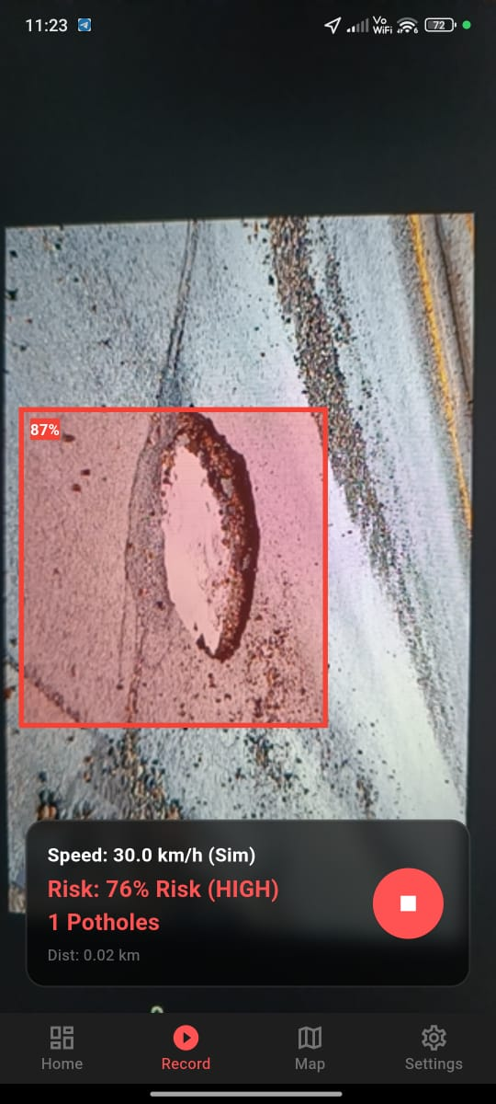
Figure 6: Real-time Camera Stream HUD with Active Pothole Bounding Box Detection

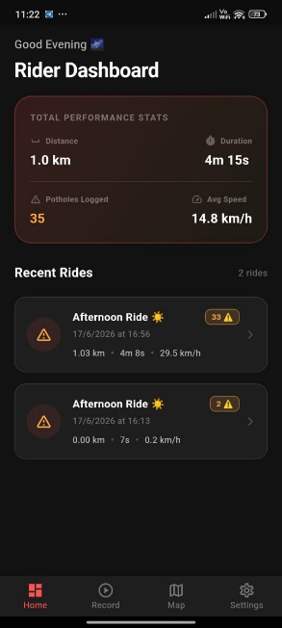
Figure 7: Strava-style Rider Dashboard showing ride history and aggregate telemetry statistics

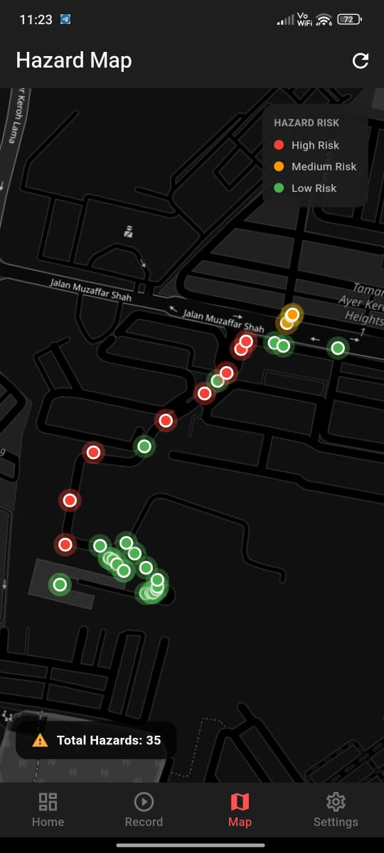
Figure 8: Dark-themed OpenStreetMap displaying aggregated safety risk hazard warning pins

- CONCLUSION
This paper has successfully presented the design, implementation, and evaluation of an AI-powered real-time pothole detection and risk assessment system for micro-mobility platforms. By deploying an optimized, INT8-quantized YOLOv8 Small model, the system achieves a frame processing latency of under fifty milliseconds, enabling local, offline-first edge inference. The integration of the velocity-scaled exponential Risk Index algorithm ensures that warning overlays and audible warnings are dynamically calibrated to the rider's speed, significantly increasing safety compared to static alerts. Quantitative benchmarking justified the selection of the Small model as the optimal balance of speed and accuracy, achieving a validation mAP50 of 95.8% with an INT8 footprint of ~12.2 MB. Future work will focus on expanding the dataset for multi-class hazard detection (cracks, debris), implementing multi-sensor fusion combining vision with smartphone accelerometers to verify impacts, and developing a secure cloud database to support crowd-sourced hazard alerts.

ACKNOWLEDGEMENTS
This research has been funded by Universiti Teknikal Malaysia Melaka UTeM).

REFERENCES
[1] G. Jocher, A. Chaurasia, and A. Jing, "Ultralytics YOLOv8," Jan. 2023. [Online]. Available: https://github.com/ultralytics/ultralytics.
[2] H. Maeda, Y. Sekimoto, T. Seto, T. Kashiyama, and H. Omata, "Road damage detection and classification using deep neural networks with smartphones," Computer-Aided Civil and Infrastructure Engineering, vol. 33, no. 12, pp. 1127–1141, Dec. 2018.
[3] A. Arya, S. Singh, and A. Singh, "Road anomaly detection using deep learning on edge devices," in Proceedings of the International Conference on Cognitive Computing (ICCC), 2021, pp. 88–95.
[4] Google Developers, "TensorFlow Lite: On-device machine learning framework," 2021. [Online]. Available: https://www.tensorflow.org/lite..
[5] Flutter Team, "Flutter: Cross-platform mobile development framework," 2024. [Online]. Available: https://flutter.dev.
[6] R. Medina-Melián, J. A. Muñoz-Salinas, and R. Muñoz-Salinas, "Real-time road hazard warning system for bicycles using edge computing and computer vision," Sensors, vol. 22, no. 15, p. 5742, Aug. 2022.
[7] K. Gopalakrishnan, "Deep learning in infrastructure applications: A review," Computational Intelligence and Neuroscience, vol. 2018, Art. no. 2697089, Oct. 2018.
[8] OpenStreetMap Contributors, "OpenStreetMap Tile Usage Policy," 2023. [Online]. Available: https://operations.osmfoundation.org/policies/tiles/.
[9] Y. Du, C. Chen, and S. Li, "An exponential velocity-scaled risk model for active collision avoidance in intelligent vehicles," IEEE Transactions on Intelligent Transportation Systems, vol. 21, no. 4, pp. 1621–1632, Apr. 2020.
[10] J. Redmon, S. Divvala, R. Girshick, and A. Farhadi, "You Only Look Once: Unified, Real-Time Object Detection," in Proceedings of the IEEE Conference on Computer Vision and Pattern Recognition (CVPR), 2016, pp. 779–788.
[11] J. Redmon and A. Farhadi, "YOLOv3: An Incremental Improvement," arXiv preprint arXiv:1804.02767, Apr. 2018.
[12] A. Bochkovskiy, C. Y. Wang, and H. Y. M. Liao, "YOLOv4: Optimal Speed and Accuracy of Object Detection," arXiv preprint arXiv:2004.10934, Apr. 2020.
[13] C. Y. Wang, A. Bochkovskiy, and H. Y. M. Liao, "YOLOv7: Trainable bag-of-freebies sets new state-of-the-art for real-time object detectors," in Proceedings of the IEEE/CVF Conference on Computer Vision and Pattern Recognition (CVPR), 2023, pp. 7464–7475.
[14] K. Chen, L. Wang, and Y. Wang, "Pothole detection using accelerometers and machine learning: A comparative study," Transportation Research Part C: Emerging Technologies, vol. 115, p. 102636, Jun. 2020.
[15] R. Fan, M. J. Basso, and Y. Liu, "Computer vision for road surface hazard detection: A systematic review," IEEE Transactions on Intelligent Transportation Systems, vol. 23, no. 8, pp. 10234–10252, Aug. 2022.
[16] M. Sandler, A. Howard, M. Zhu, A. Zhmoginov, and L. C. Chen, "MobileNetV2: Inverted Residuals and Linear Bottlenecks," in Proceedings of the IEEE Conference on Computer Vision and Pattern Recognition (CVPR), 2018, pp. 4510–4520.
[17] TensorFlow Authors, "Post-training integer quantization for edge model optimization," 2022. [Online]. Available: https://www.tensorflow.org/lite/performance/post_training_integer_quant.
[18] Y. Jo and S. Ryu, "Pothole detection system using a black-box camera," Sensors, vol. 15, no. 8, pp. 18816–18831, Aug. 2015.
[19] R. A. Kroeger, "Dynamic vehicle risk alerting using GPS and smartphone telemetry," IEEE Transactions on Vehicular Technology, vol. 69, no. 11, pp. 12903–12912, Nov. 2020.
[20] H. Maeda, M. M. I. Chowdhury, and Y. Sekimoto, "A global benchmark dataset for road damage detection using smartphones," in Proceedings of the IEEE International Conference on Big Data, 2020, pp. 5321–5330.

BIOGRAPHIES OF AUTHORS

 | Wan Mohd Yaakob Wan Bejuri  received his Ph.D., Master and Bachelor Degree in Computer Science from Universiti Teknologi Malaysia in 2019, 2012 and 2009. Previously, he was received Diploma in Electronic Engineering in 2005 from Politeknik Kuching Sarawak. He is currently a senior lecturer at Universiti Teknikal Malaysia Melaka. For detail, please visit to: http://teknologimalaysia.academia.edu/WANMOHDYAAKOBWANBEJURI. He can be contacted at email: wanmohdyaakob@gmail.com.

